**Feature:-FAQ**

FAQ Displayed

|  |  |  |
| --- | --- | --- |
| Field Name | Data Type | Required (Not Null) |
| QuestionID (Primary Key) | Numeric | X |
| Question Title | Text 255 Characters | X |
| Question Description | Text 500 Characters | X |

FAQ Incoming Question

|  |  |  |
| --- | --- | --- |
| Field Name | Data Type | Required (Not Null) |
| IncomeID (Primary Key) | Numeric | X |
| User First Name | Text 255 Characters |  |
| User Last Name | Text 255 Characters |  |
| User Email | Text 255 Characters | X |
| Question Title (Drop Down List) | Text 255 Characters | X |
| Question Description | Text 500 Characters | X |

Events Feature

|  |  |  |
| --- | --- | --- |
| Field Name | Data Type | Required (Not Null) |
| EventID | Numeric | X |
| Event Title | Text 255 Characters | X |
| Event Description | Text 2000 Characters | X |
| Image | ? |  |
| Date | date | X |
| Time | time | X |
| Location | Text 255 Characters | X |

**Feature:- Blogs**

**Table name: blogs**

|  |  |  |
| --- | --- | --- |
| **Column Name** | **Data type** | **Description** |
| id | INT (Primary Key), Auto Increment | A unique identifier, Not Null |
| blog_Title | VARCHAR (255) | Not Null |
| blog_Content | MEDIUMTEXT | Not Null |
| blog_Date | DATE | Not Null |
| blog_Author | INT (FOREIGN KEY) | Not Null, referenced to column admin_Id in table admins. |

**Table Name: comments**

|  |  |  |
| --- | --- | --- |
| **Column Name** | **Data Type** | **Description** |
| id | INT (Primary Key), Auto Increment | Unique identifier, Not Null |
| comment_Content | VARCHAR(255) | Not Null |

**Table Name:blogsXcomments**

|  |  |  |
| --- | --- | --- |
| **Column Name** | **Data Type** | **Description** |
| blogsXcomments_Id | INT (Primary Key), Auto Increment | The unique identifier, Not Null |
| comment_Id | INT (FOREIGN KEY) | Not Null, referenced to column id in table comments. |
| blog_id | INT (FOREIGN KEY) | Not Null, referenced to column id in table blogs. |

**Database schema: Blogs Feature**

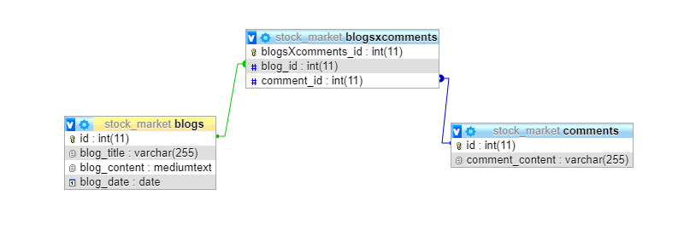

**Feature: Login and Registration**

**Table name: users**

|  |  |  |
| --- | --- | --- |
| **Column Name** | **Data Type** | **Description** |
| user_id | INT (Primary Key), Auto Increment | The unique identifier, Not Null |
| login | VARCHAR(50) | Not Null |
| user_email | VARCHAR(50) | Not Null |
| password | VARCHAR(20) | Not Null |
| user_Fname | VARCHAR(50) | Not Null |
| user_Lname | VARCHAR(50) | Not Null |
| userPhone | VARCHAR(50) | Not Null |
| status_id | INT (FOREIGN KEY) | Not Null, referenced to column id in table status |

**Feature: Contact Us**

**Table name: contacts**

|  |  |  |
| --- | --- | --- |
| **Column Name** | **Data Type** | **Description** |
| Id | INT (Primary Key), Auto Increment | The unique identifier, Not Null |
| name | VARCHAR(50) | Not Null |
| email | VARCHAR(50) | Not Null |
| subject | VARCHAR(50) | Not Null |
| message | text | Not Null |

**Feature: User Status**

**Table Name: status**

|  |  |  |
| --- | --- | --- |
| **Column Name** | **Data Type** | **Description** |
| status_id | INT (Primary Key), Auto Increment | The unique identifier, Not Null |
| content_post | VARCHAR(50) | Not Null |
| date_post | DATETIME | Not Null |
| user_id | INT (Foreign) | Not Null referenced to column user_Id in table users. |

**Table Name: comments**

|  |  |  |
| --- | --- | --- |
| **Column Name** | **Data Type** | **Description** |
| comment_id | INT (Primary Key), Auto Increment | The unique identifier, Not Null |
| comment_post | VARCHAR(50) | Not Null |
| date_post | DATETIME | Not Null |
| status_id | INT (Foreign) | Not Null referenced to column status_Id in table status. |

**Table Name: status comments**

|  |  |  |
| --- | --- | --- |
| **Column Name** | **Data Type** | **Description** |
| statusXcomments_Id | INT (Primary Key), Auto Increment | The unique identifier, Not Null |
| status_Id | INT (FOREIGN KEY) | Not Null, referenced to column comment_Id in table comments. |
| comment_id | INT (FOREIGN KEY) | Not Null, referenced to column blog_Id in table blogs. |